Name: Date: ea words 1

The long (e) sound is often represented by the letters ea when it comes in the middle of words, like in the words below.

Remember: Say the word aloud, then say each letter aloud as you write it e.g. 'reach, r ... e ... a ... c ... h'

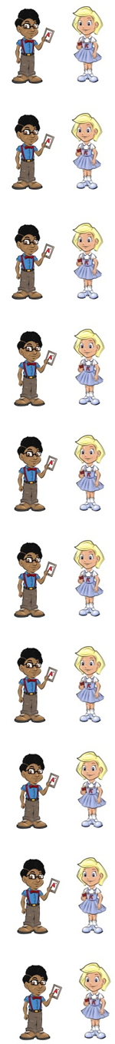
How high can you reach?

You should teach younger children the right things.

A beach has lots of sand on it.

You need to keep your dog on a lead.

Do you like to read books?

A leaf grows on a tree.

Nina will not leave Gail alone.

If you are not strong, you are weak.

To speak means to talk.

A cut needs time to heal.

Now test yourself without looking at the words and check for yourself if you got them all right. Practice writing any words that you made mistakes on again.

© www.SaveTeachersSundays.com 2013
Name: Date: ea words 1

The long (e) sound is often represented by the letters ea when it comes in the middle of words, like in the words below.

Remember: Say the word aloud, then say each letter aloud as you write it e.g. 'reach, r ... e ... a ... c ... h'

Try to spell each word without looking at it.

How high can you ?

You should younger children the right things.

A has lots of sand on it.

You need to keep your dog on a .

Do you like to books?

A grows on a tree.

Nina will not Gail alone.

If you are not strong, you are .

To means to talk.

A cut needs time to .

Now check for yourself if you got them all right. Practice writing any words that you made mistakes on again.

© www.SaveTeachersSundays.com 2013

